Name:____________________________ HR:________ Date:_____________
Continents and Oceans
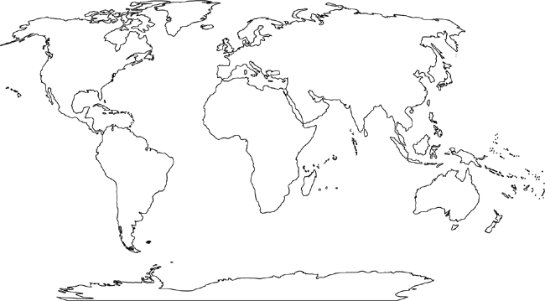
Directions: Label each continent and the oceans, then color each continent green and the oceans blue. Make sure you can see the labels!

