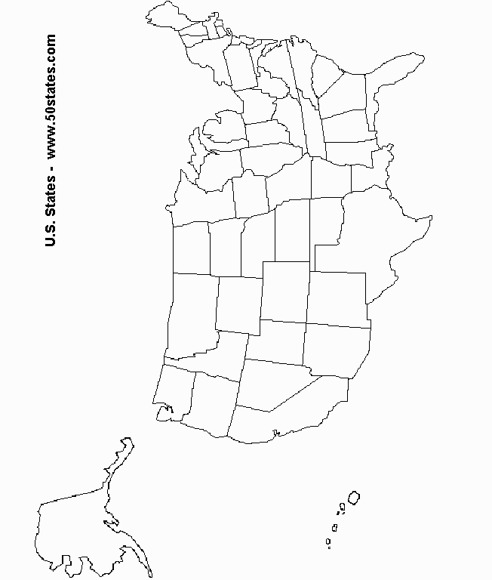
Name:____________________________ HR:________ Date:_____________

United States Regions
Directions: Using pages 30-31 in your book, label the states and then color each region as follows:
West: Orange, Mountain: Purple, Southwest: Yellow, Southeast: Green, Midwest: Blue, Northeast: Red

